u
Northgate Lodge Camp Indemnity Form

DISCLAIMER / INDEMNITY FORM
PLEASE READ CAREFULLY, REGISTRATION & PAYMENT TO ATTEND EVENTS IS ACCEPTANCE THAT DISCLAIMER HAS BEEN READ AND UNDERSTOOD.
Terms and Conditions:
This event is made possible by permission of land owners and occupiers of land. I accept they have given permission on condition that I release and indemnify them from any liabilities, claims, losses, damages or expenses whatsoever including any liability under the Health and Safety at Work Act 2015.

I understand that participating in the event involves a risk of injury or death.
In entering the event I understand that I have sole responsibility for my horse, equipment, vehicle and other possessions during the period of the event.

By participating I expressly accept all risks personally and release the organisers, land owners / occupiers and other persons involved in the event from any liability, claims, damages or expenses caused by the event, including but not limited to any personal injury or death, any emotional or nervous disorders, any medical condition or suffering, any property loss or damage.

We expect the following rules to be adhered to while on camp:
• Your children to wear helmets at all times when mounted.
• To follow basic safety procedures when handling and riding horses.
• Your children to behave sensibly and to consider the needs of others.
• To adhere to all instructions from coaches and camp staff.

Riders Name: _______________________________________________________________________

I ____________________________________ (Parent of rider), accept the risks involved in equestrian and camp activities and will not hold the Thomas family or Northgate Lodge liable for any accidents or injuries to rider or gear while attending the Northgate Lodge Camps.

Signed: ____________________________________________ Date:______________________________

Please ensure that your horse has been recently wormed and is free of bot eggs, lice and ticks and is not sick or coughing.
Make sure their hooves/shoes are in good condition.
Northgate Lodge Camp Registration Form
Thank you for booking into the Northgate Lodge Camp. Please fill in the Registration and Indemnity forms and forward to us at your earliest convenience.
A non refundable $50 booking fee will need to be deposited into the following bank account to confirm booking - Northgate Lodge: Rabobank 03-1353-0249578-00 or post 88 Peter Snell Road, Ruakaka 0116
Registration Form
Riders Name: _________________________________ Male/Female Age: _________________________
Parents Name: __________________________________________________________________________
Emergency Contact Numbers: ______________________________________________________________
Address: _______________________________________________________________________________
Email Address: _____________________________________ Staying overnight YES / NO
Is your child on any medication or do they have any medical conditions we should be aware of? Yes/No If yes please list: _________________________________________________________________________
Any allergies/dietary requirements? ________________________________________________________________________________________
Riding Ability: Circle which level
Novice (can canter, trot poles/30cm) Intermediate Jumping 50cm – 70cm
Advanced Jumping 80cm – 1m Advanced + Jumping 1m +
Confidence Level: Excellent / Average / Poor Pony Club certificates: None / D / D+ / C / C+ / B

Horse Name: _________________________________ Age: ______________________ Mare/Gelding
Any riding issues? What type of riding would you like to focus on while on camp? _____________________________________________________________________________________
_____________________________________________________________________________________
_____________________________________________________________________________________
Any health concerns? _____________________________________________________________________________________
_____________________________________________________________________________________
Any other information to help us ensure your child’s enjoyment of camp?
_____________________________________________________________________________________
_____________________________________________________________________________________

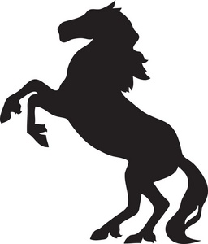

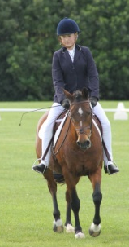
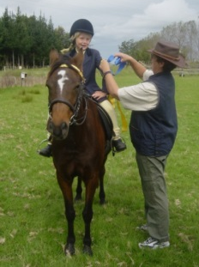
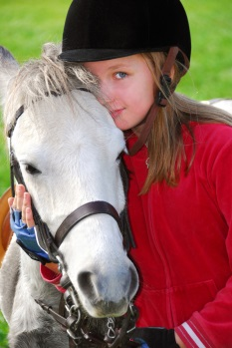
Wondering what to do with the kids and ponies
during the school holidays??
Northgate Lodge will be holding sleepover camps at the
equestrian facility in Ruakaka.
There will be dressage and jumping lessons, horsemastership, games,
beach riding, and heaps of fun!!!
WHERE: Northgate Lodge, 88 Peter Snell Road, Ruakaka, Whangarei
WHEN: Monday April 26th to Thursday April 29th 2021
COST: $300 incl gst—includes food and overnight accommodation, lessons and fun!!
Discounts for more than one child from the same family
AGES: 7-16 years for sleepover camp (approx.)
RIDERS - Must be competent at least trotting off the lead.
Day campers are welcome to attend camp during the day time 9am-5pm at a cost of $60 incl gst per day.
Horses can stay overnight for $15 a night.
What to bring:
• Your pony with all of their tack, grooming kit, water bucket, covers and feed/hay
• You with all of your riding gear, helmets, jodphurs, wet weather gear, back protector if needed
• Sleeping bag, pillow, towels, toiletries, torch, clothes, swimming gear
• One container of home baking to share, any medication if required
Please ensure that your horse has been recently wormed and is free of bot eggs, lice and ticks and is not sick or coughing.
Make sure their hooves/shoes are in good condition.

